**RF Circuit Design – Exercise #10??**

1. The following small signal model describes a CMOS amplifier:

vs

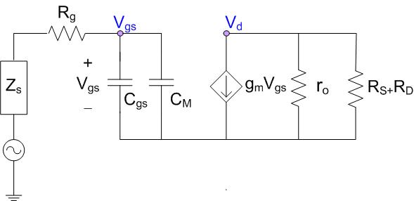

Zin

RL

Cdg



D

G

S

1. Find *ft* and *fmax* of the transistor at the given operating point, assuming that Cgs=15fF, Cgd=5fF, Rg=5W, the overdrive voltage (VGS-VTH) is 0.2V, the current ID at the operating point is given by: ID = k(VGS-VTH)2 with k=0.05mA/V2, the voltage supply is VDD=0.9V and the IV curve of the transistor is given by the following figure:

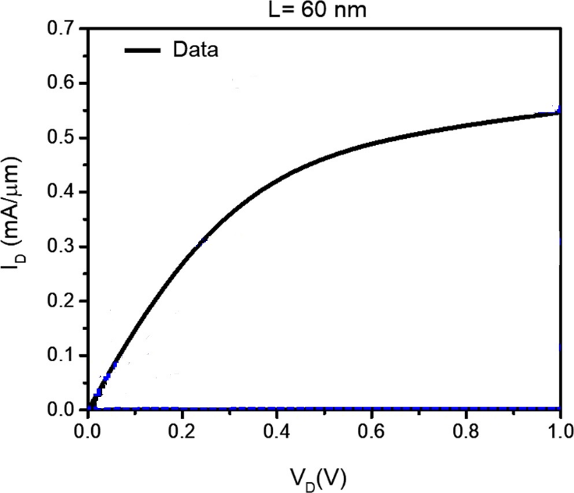

ID [mA]

Figure 1 – IV curve of a 0.2V overdrive voltage

1. Repeat Section i above, assuming now that Cgd can be neglected. What is the error (in percentages) between the exact calculation and the approximated one?
2. Repeat Section i above, assuming now that the width of the transistor (W) has twice the size than it had in Section i. In your calculations specify what parameters are affected by this change, and why.
3. Repeat Section i above, assuming now that the number of fingers of the transistor (N) has twice the size than it had in Section i. In your calculations specify what parameters are affected by this change, and why.
4. For the small signal model of the transistor that is given in Question 1 Section i above, design an octagonal inductor that will match the output of the transistor to 50W at 10GHz, assuming that the inductor is implemented by a top metal layer made of copper (conductivity of s=5.96×107 S/m) with a cross section of 2mm x 2mm, surrounded by Silicon Dioxide with er=4.1. The inductor should include 2 windings (turns) with a spacing of 1mm between them. Follow the steps below:
5. Find the required inductance for the matching.
6. What is the approximated area of the inductor?
7. What is the Q factor of the inductor?
8. Estimate is the SRF of the inductor, assuming that only the parasitic capacitance between the windings affects the SRF.
9. What will be the insertion loss of a mixer based on a switch if the LO signal will be a rectangular waveform with a duty cycle of 33%? (meaning, the pulse width is T and the total time period is 3T).
10. An RF switch is implemented by the resistor that is presented in figure 1 (biased with an overdrive voltage of 0.2V).
11. Find the Ron of a switch.
12. What can be done in order to lower this resistance to 10W or below?
13. What will be the insertion loss of the switch if Ron will be 10 W?